**AGENCY BACKGROUND**

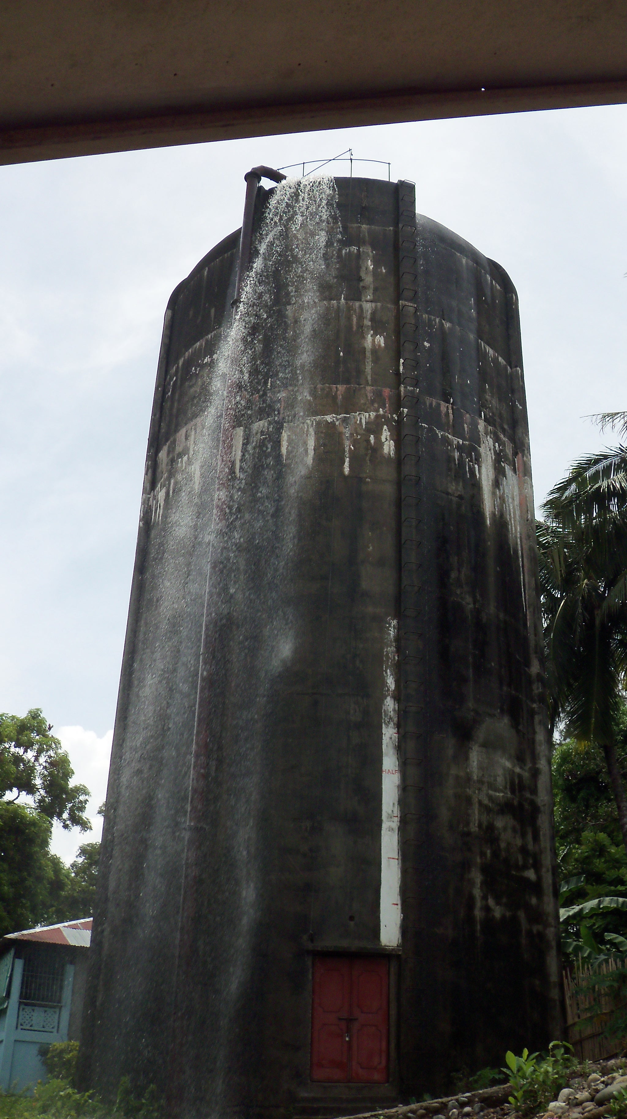

The water supply system of Masinloc was constructed in 1950 by the NAWASA. The authority constructed a 380 cubic meter elevated reinforced concrete tank for storage which was supplied by an adjacent water deep well. After five ( 5 ) years of operation, the water well became blackish thus necessitating the second well in Sitio Hawaii. This power driven well became uneconomical due to its high fuel consumption which led to higher operational cost

In 1964, a new water source was opened at Bulsa Spring having an initial funding of ₧ 500,000.00 from a loan provided by the Development Bank of the Philippines (DBP). This loan was used for the installation, construction of some 7.3 km. of 150mm diameter pipes and other related sourcedevelopmental works. In 1965, the municipality took over the operation of the water system from NAWASA.

The Masinloc Water District acquired the ownership and management of the system in accordance with Presidential Decree No. 198. LWUA awarded the Conditional Certificate of Conformance on February 07, 1990 with CCC No. 430.

 380 cu.m Elevated Concrete Tank

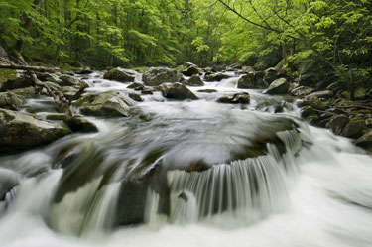



COMPANY PROFILE

**Company Name :MASINLOC WATER DISTRICT**

**Company Address : Mamacoy Road**

**Municipality : Masinloc**

**Province : Zambales**

**Zip Code : 2211**

**Region : 3**

**No. of Barangays in the Municipality : 13**

**No. of Barangays Served : 7**

**Classification of Office : Government Owned and Controlled**

**Corporation**

**Total Employees : 14**

**Mission :**

WE will provide reliable and high quality water, water services at a fair price to meet the needs and expectation of our customers.

WE will protect the environment to conserve our water resources for future generations.

WE will conduct ourselves in accordance with the highest ethical standards because our reason for being is to serve the PUBLIC.

**Vision :**

We are a water utility firm committed to service excellence, improving water services of the COMMUNITY.

**PRESENT CONDITION OF WATER SUPPLY SYSTEM**

The water supply system of Masinloc comes from the Local Water Utilities Administration

(LWUA) through the Masinloc Water District. It obtains its supply from Bulsa Creek, the main water source for Masinloc Water District. It is about 7300 meters from the service area and has an elevation of 103 meters from the reservoir and with total source production of about 100 lps during the wet season and 30 – 40 lps during the dry season. Water supply from the creek is available throughout the year and is supplying water for 1747 service connections. Water is distributed by gravity through 150 mm and 200 mm transmission line. The 200 mm line goes into the 380m³ elevated tank while the other line is fed directly to the distribution system. Water is available 24 hours with sufficient pressure in 2 barangays only, while the rest have scheduled water service of 14 to 16 hours.

The raw water from Bulsa Creek is normally clear most of the time. Water treatment is done through disinfection by hypochlorination. The water supplied by the Water District is mainly for domestic use, specifically for drinking, bathing, and washing.

The water quality of Bulsa Creek meets the National Standard for Drinking water. ( NSDW )

**FINANCIAL ASPECT :**

The Water District adopts a progressive charging for the consumers. A minimum charge of ₧ 160.00 is being charged for residential consumers as well as government institutions for the first 10m³, while for commercial establishments the minimum charge is ₧ 220.00 for the first 10m³. Average monthly consumption is approximately 30m³.

The district divided the service area in 11 zones. Reading is done for the first 7 working days and distribution of billing is 7 days after reading. Payment due date is another 7 to 9 days after the distribution. A penalty of 10% is imposed after the due date as per policy of the district.

Water meters are read monthly in each service area on scheduled dates. Any service defects either complained of or not are reported in a Maintenance Order form.

A monthly billing summary is prepared for all water bills issued during the month..